EDUC 300 Philosophy of Education
What’s your current view of …?
What is real | 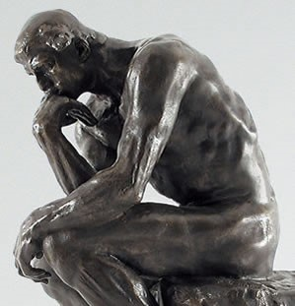
What is true
What is valuable
The student
The teacher
The curriculum and instructional methods
The purpose of education
The concept of life calling

