Traditional Philosophies & Education
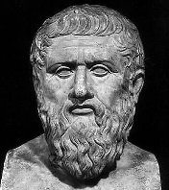
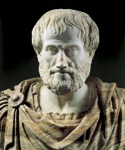
EDUC 300 / CORE 310
 | Idealism | Realism | Neo-Scholasticism
When? Who?
Main emphases or essential concepts
What is real? - metaphysics
What is true? - epistemology
View of values – axiology, ethics
View of aesthetic values
View of the student
View of the teacher
View of the curriculum
(Best subjects? Why?)
Purpose of education
View of work

Biblical?

Pros

Cons

Pick a picture, song, or pose for each -ism
Questions?

