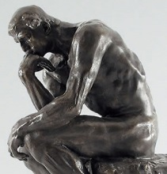
Traditional Philosophies & Education
EDUC 300 / CORE 310
 | 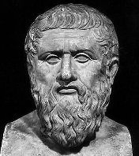  Idealism | 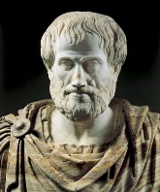  Realism | Neo-Scholasticism
In a nutshell | Idea-ism | Real world observations | Human reason
When? | 427-347 BC | 384-322 BC | 1225-1274
Who? | Plato (Athens) | Aristotle | Thomas Aquinas
Main emphases or essential concepts | Universal, a priori truths  Otherworldly  Pure ideas | Truth through observation  Reality is the physical world | Aristotle + Christianity
View of truth  (What is real?) | Pure ideas  Independent of experience, universal concepts/ideas | Observable facts (based on senses)  Let objects speak for themselves | Pure reason, logic  Known through reason and intuition + supernatural revelation
View of values | External to humanity; ethical life is lived in harmony with the universe | Nature has a moral law | Good people are rational people. Don’t let your will or emotions lead you astray.
View of aesthetics | Depict the world as the Absolute Self sees it | Nature contains the criteria for beauty | Meaning in art can be intuited.  (Notice it has to “mean” something.)
View of the student | Microcosmic self becoming more like Absolute Self  Striving for perfection  Intellect is the most important aspect. | Functioning organisms who can perceive the natural order; not free – subject to natural law; need to be reinforced w/behaviorism.  Student responds to envir. Stimuli. | Rational being with a natural potential to acquire truth and knowledge.  The mind needs to be developed like a muscle.
View of the teacher | Living examples of what students can be; pass on knowledge of reality | Give accurate information about reality in the quickest and most efficient manner | Mental disciplinarians.  Decides what should be learned.
View of the curriculum  (Best subjects? Why?) | Should be formed around subjects that bring students into contact with ideas.  Pure mathematics – it’s based on a priori principles. | Should emphasize the real world.  The sciences – show us the laws of nature.  Use the senses (e.g., visual aids, field trips) to learn. | Explain the world and train the intellect.  Subjects with internal logic are best.  Like math – closest to Pure Reason.  Foreign language also train the mind.
Purpose of education | Preserve the heritage; pass on the knowledge of the past. | Transmit knowledge that has been settled upon by those with a clear concept of empirical science and natural law. | Conservative social function.  Train minds.
View of work | Be as philosophical as possible?  Focus on ideas, ideals, in harmony with the universe and the Absolute Self? | Be rooted and observant.  Work with the natural order. | Use reason.  Create meaning.
Pros | Universal truths | Focus on what’s “real,” observable | Human rationality + intuition + supernatural revelation. God = source of truth & logic.
Cons | Greek dualism. Annoying to think our everyday life is just shadows on a wall! | We just “know” there’s more beyond what we can perceive with our senses | Where’s the heart? Where are the emotions?
Picture or song for each -ism | Don’t pick a cave! That’s been taken.

